6.64: a) From Eq. (6.7),
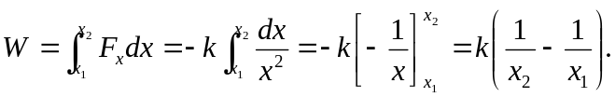
The force is given to be attractive, so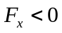 , and k must be positive. If 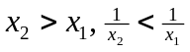, and 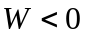. b) Taking “slowly” to be constant speed, the net force on the object is zero, so the force applied by the hand is opposite 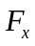, and the work done is negative of that found in part (a), or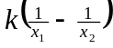 , which is positive if 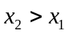. c) The answers have the same magnitude but opposite signs; this is to be expected, in that the net work done is zero.

